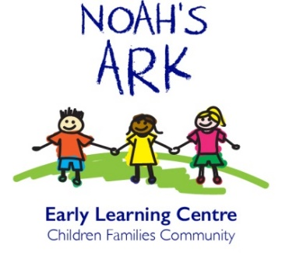

NOAH’S ARK PLAYSCHOOL
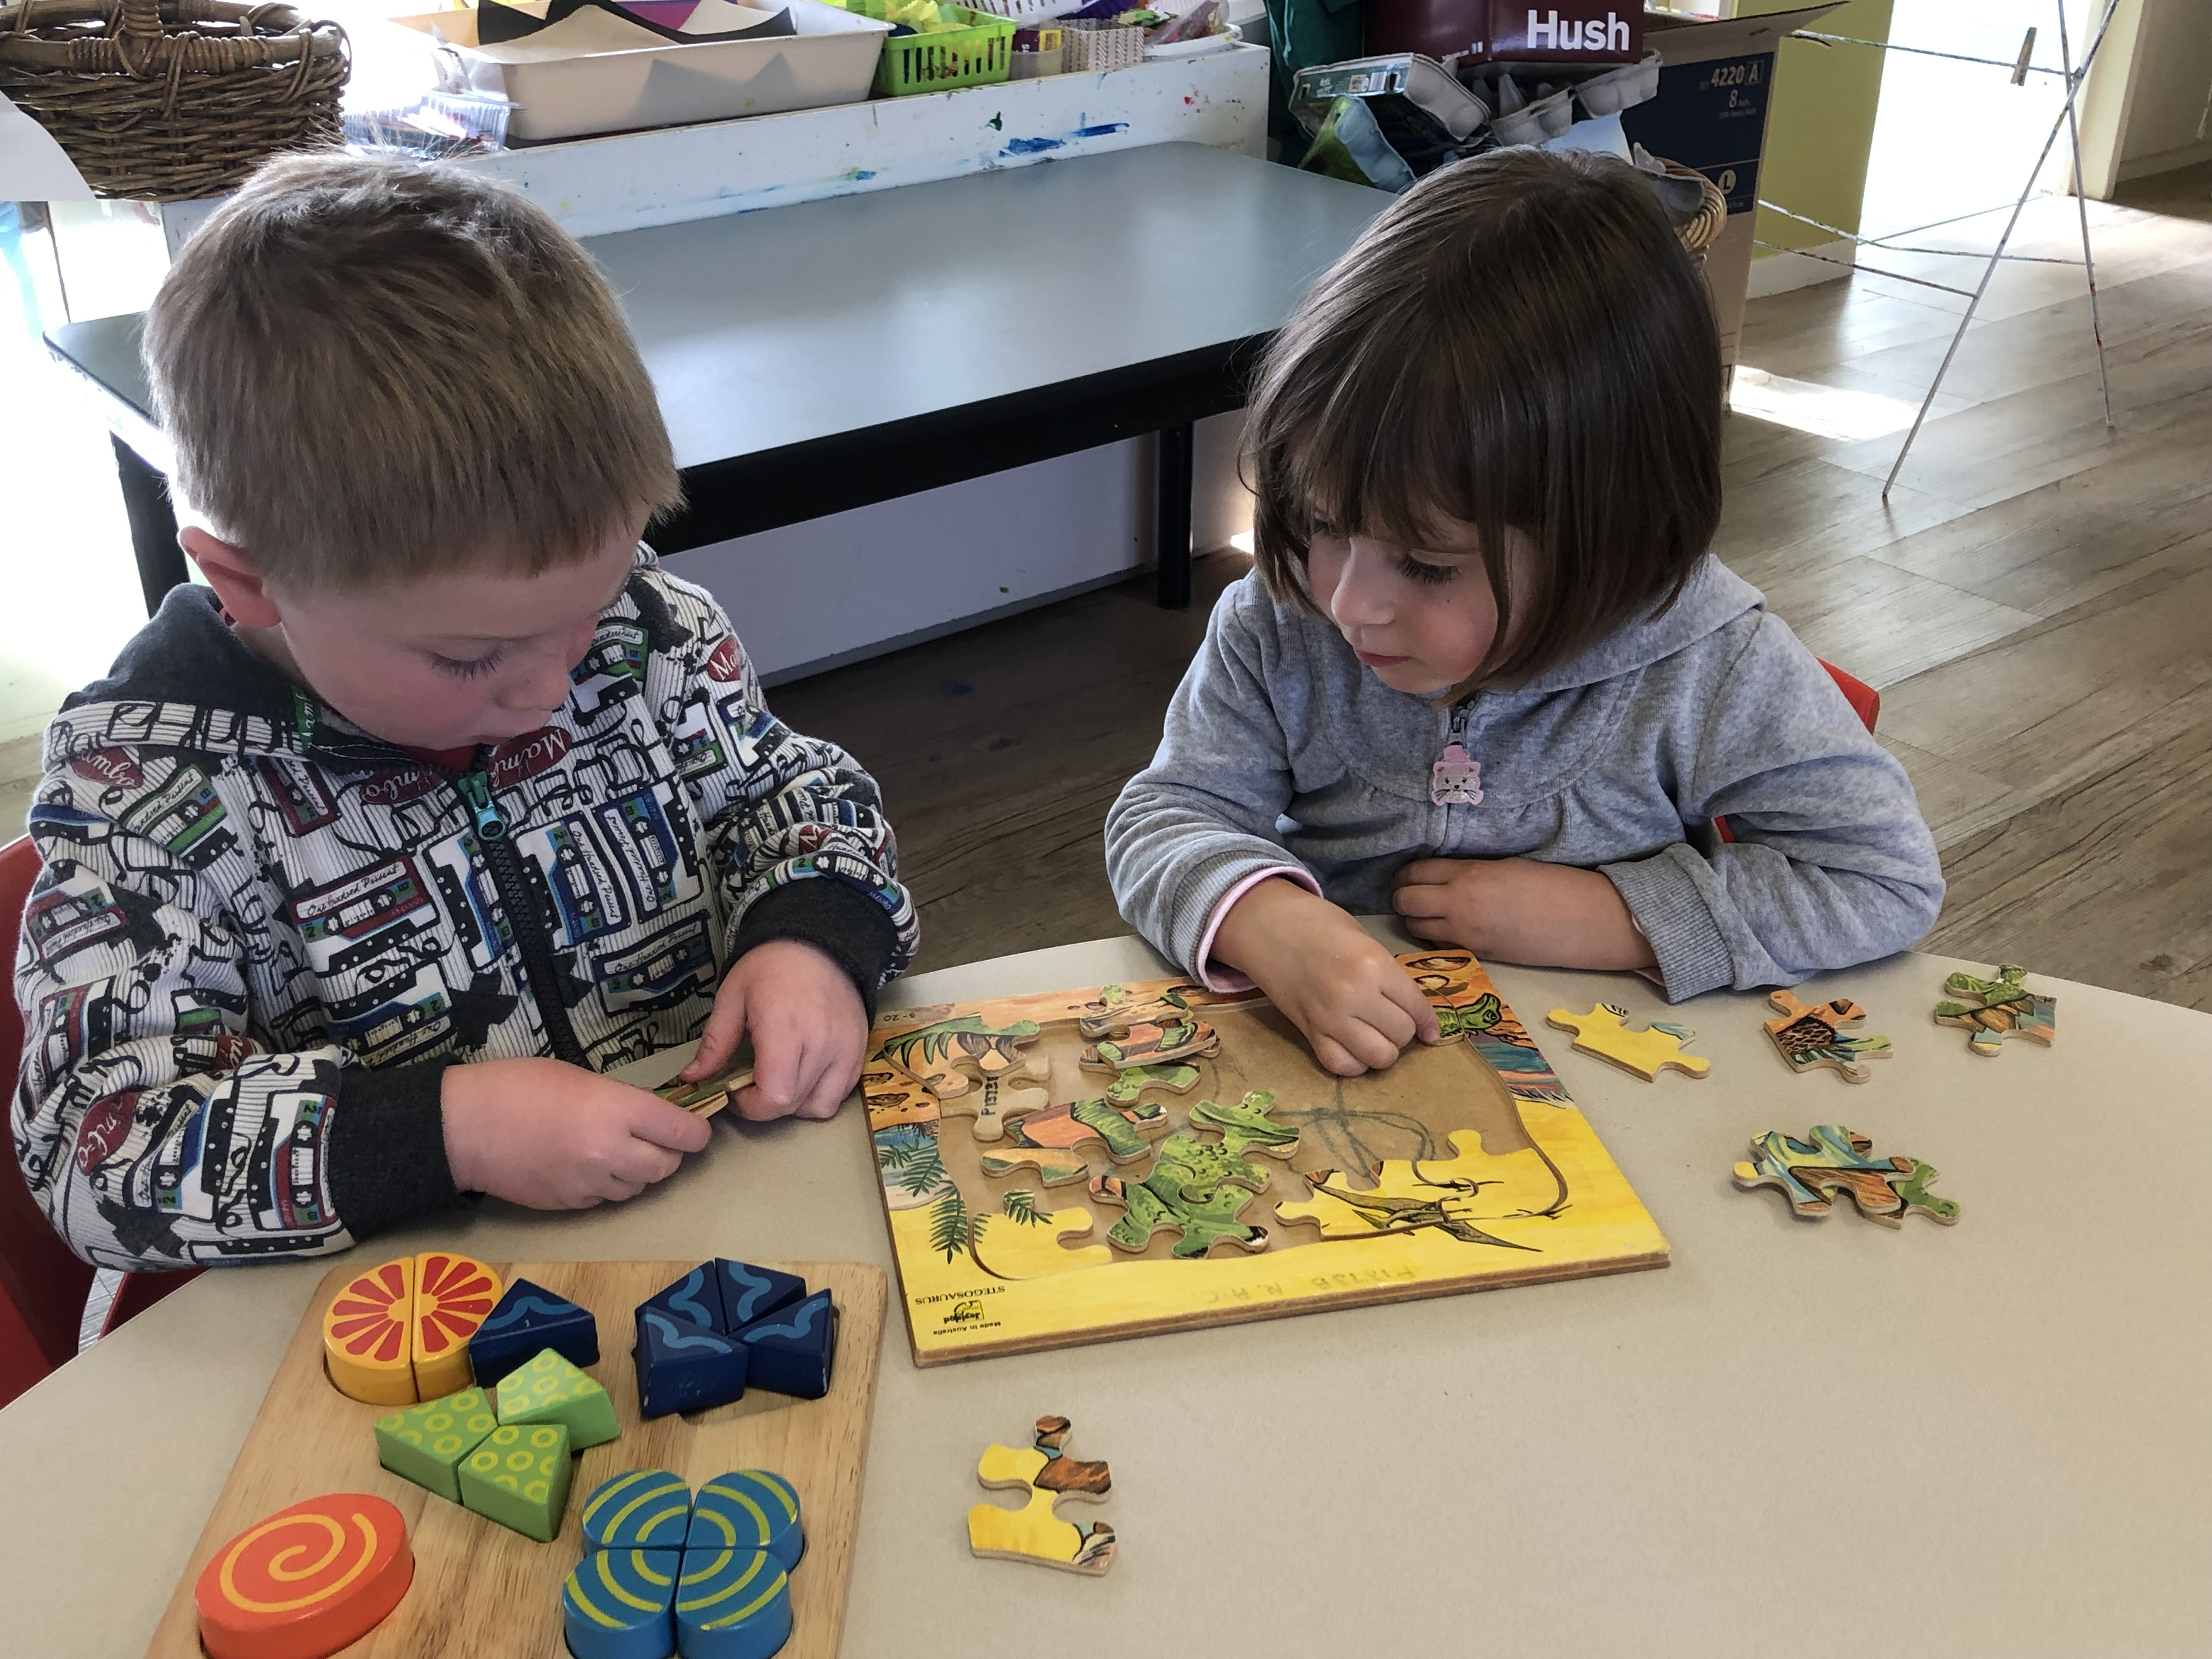
Handbook
Contact Details:
Tania Hedges (Playschool Co-Ordinator/Manager)
Phone: 02 6287 1117
Email: director@noahsarkact.com.au
Welcome to Noah’s Ark Playschool
We are excited to welcome you to Playschool and cannot wait to have you as part of our Playschool family. We look forward to learning, playing, and growing with you!

Philosophy of Learning Environment

At Playschool we provide enriched learning environments filled with knowledge and imagination. Both indoor and outdoor environments are tailored to support children's interest, individual needs and strengths. The environments will provide the children with opportunity to develop relationships with one another and work collaboratively together. Families and children are both welcome to have input and share ideas in relation to the environments.

The environments encompass opportunity for children to engage with literacy, mathematics, creative arts, nature and scientific concepts. Educators follow children's cues, scaffold and facilitate their play and learning when required.

Our educators respect the importance of culture and diversity and provide environments that reflect the cultures of the children and assist with the development of their identities. Our educators also value the importance and need to incorporate Indigenous perspectives into the learning environments to educate the children regarding inclusion and diversity.

Description of the Program Delivery

Our program aims to reflect the standards as set out by the National Quality Framework and the Early Years Learning Framework for children aged 0-6. This is an Australian government approved framework that is designed to ensure all children in education settings receive quality teaching and achieve the required learning outcomes set out in the National Framework.

Our program is based on the individual interests of each child and reflects a planning cycle with observations, reflections, follow-ups, and extensions. The program places emphasis on the development of key literacy concepts, science, language and mathematical skills. The program also fosters the development of social and emotional skills to assist with the overall development of each child’s wellbeing.

At Playschool we recognise the importance of children’s voices and our educators encourage children to share their interest and ideas. Our program is designed to provide children with the skills for lifelong learning and the knowledge and confidence to prepare them for their transition to school.

Furthermore, culture and diversity are honoured in our program as we recognise the valuable contribution that different ways of being can make to society. Our educators understand the importance of incorporating each child’s culture and heritage into the program to foster their emerging self-identities. The Playschool staff encourages all families to assist with the incorporation of their traditions, customs and languages. Additionally, Playschool staff value the importance and need to incorporate indigenous perspectives into the program and learning environments to educate the children regarding history, inclusion and diversity.

ENROLMENT INFORMATION

Prior to enrolment parents are required to complete the confidential enrolment form and provide copies of immunisation records. At the beginning of each year parents may be invited to attend an information session at which time the operation of the Playschool will be discussed. We will be happy to answer any questions you may have on this occasion.

It is important that you notify the office of any changes to enrolment information. Changes to phone numbers, address, emergency contact etc. are required to be updated if and when needed.
By law we require current immunisation statements on file. The relevant vaccinations are those under the National Immunisation Program (NIP), which covers the vaccines usually administered before age five. These vaccinations must be recorded on the Australian Childhood Immunisation Register (ACIR).

CANCELLING/FORFEITURE OF A PLACE IN PLAYSCHOOL

We require a minimum of two weeks notice if you intend to withdraw from the program. Families who will be away for an extended period but wish to reserve a place in their absence, must continue to pay fees while they are away to do so.

If your child will not be attending Playschool on any day, please notify the staff. If a child fails to attend a session on three consecutive occasions without notification to the Centre, the Director has the authority to cancel that child’s place in the program. The Centre will write to your last known address to inform you of this action.
FEES AND FINANCIAL MATTERS
Fees

Noah’s Ark Resource Centre Board of Management has responsibility for the Playschool and for decisions relating to financial management. Playschool fees are charged on a term basis (10week periods) and are payable by the due date on the invoice. The following options are available:
- Direct deposit in to the nominated bank account.
- EFTPOS via the main building
- Credit Card payment over the phone
- Xplor home app
Sessions are charged at $61 per session (before CCS is eligible).

Reminders are sent to families for payment for two weeks after the due date. If the account is not settled by the end of current term care for the following term will not be guaranteed. Any outstanding money due by end of current term will be passed on to the CEO of Noahs Ark Early Learning to pursue.

Special arrangements for meeting fee payments may be possible and parents should discuss this matter with the Program Manager.

PLEASE NOTE: Families must pay for every session each term and unfortunately missed sessions cannot be made up.
LATE PICK UP
Parents/Carers must notify staff at Rivett (head office) on 6287 1117 if you are going to be late collecting your child. The staff at Rivett will then notify the relevant session that your child attends. (This includes The Shepherd Centre)
If the child remains at the Centre more than 15 minutes after the conclusion of the session and we are unable to contact you, educators will contact the person nominated by you to collect your child.

LEAVING AND COLLECTING CHILDREN
When you bring your child to the Centre you are welcome to stay and help him/her settle in but please be guided by the educators in this matter.
You are required to sign your child in and out on the attendance sheet at each session. This is how we determine that all children are accounted for in an emergency, or if we need to evacuate the building. The sign in book will be located at the entrance to the Playschool room. It also requires you to record a contact phone number where you can be reached during that session.
PLEASE NOTE: Written authorisation is required, and educators must be notified, if you arrange for another person to collect your child. Unless we have written permission from the parent, a child will not be released into the care of another person. An authorisation form is available for your use.

Playschool Staff

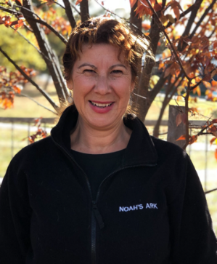
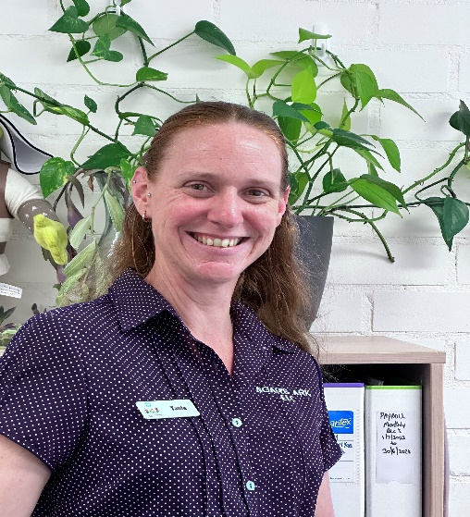
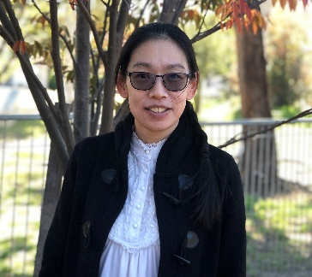

Mary Piris- Head Educator Grace Kew- Assistant Educator Tania Hedges- Playschool Director

Flexible Routine
Arrival
We ask that parents/carers sign their child (ren) in on the provided sign in sheet detailing pick up time (2:30pm) and the best contact information (person and mobile number) for the day should the need arise to contact you during your child’s time at Playschool.
We encourage the children to place their bags on their hook (identified by their name tag) and unpack their bag into the labelled baskets- Morning Tea, Lunch and Drink Bottle in preparation for class opening at 9:30am
09:30-10:00 Morning Session
The tables and mats at Playschool are set up with a wide range of activities available for the children to engage and play with. These activities include, but are not limited to, arts & crafts, fine motor skill experiences, imaginative play, building and puzzle work. We encourage parents/carers to stay, play and settle in their child if needed.
10:15-10:30 Morning Group Time
During our morning group time, the Playschool children and their educators sit together and welcome each other to the room. Educators then ask the Playschool-ers what they would be interested in learning throughout the week, and we explain what experiences are already planned for the day. The children are encouraged to participate but are also offered quiet activities if they are not interested in the group time.
10:30 - 11:00 Morning Tea
Children are supervised with hand washing and encouraged to use the toilet prior to collecting their own drink bottle and Morning Tea from the labelled baskets and sitting for Morning Tea. The children and educators all sit together, and this is an opportunity for them to engage with one another.
11:00 – 12:30 Outdoor Play

This is a time for free play outdoors and there is an opportunity to play organised games together as a group. There are a wide range of activities are available for all children to engage with including, but not limited to sandpit play resources, construction, cubby house, swing set and slide, obstacle courses set out by the educators. Weather permitting water play is organised with prior notification to parents/carers.

12:30-13:00 Midday Group Time

This midday group time is educator led with interested children grouping together to talk about different topics of discussion in relation to the week’s planned program, read books, share ideas and to prepare for lunch.

13:00- 13:30 Lunch

This is a time where the children sit together to share stories and engage with each other during their meals with peers and educators.

Children who are enrolled for the 9:30-1:30 session of Playschool are collected by their parent/carer and we ask that they be signed out accordingly on the sign in sheet prior to departure.

13:30-13:45 Rest and Relaxation

As the children finish their lunches, they are encouraged to put their own lunch containers and water bottles into their bags in readiness for home time. Children are then encouraged to move to the carpeted area for rest and relaxation. This is an opportunity for children who request/need to sleep are provided with bedding and linen and for other children to participate in quiet rest and relaxation activities that can include puzzle tasks, reading, listening to calm, soothing music or participate in guided mediation. These activities aim to assist children to consciously rest and relax, recognise their need for calm and self- regulation and allow them to rejuvenate and be refreshed for the rest of their day.
13:45-14:20 Free Play and/or Planned Experiences.

This is a time for children to engage in child led play-based experiences and/or educator led planned experiences.

Planned Experiences

Experiences are set up in accordance with the weekly program. These experiences are often intentional teachings based on individual or group observations made in the previous week. All children can participate in these experiences that cater for various areas of development. Every day is different at Playschool, so there are also times in each day where spontaneous experiences take place and are developed from the children’s emerging interests and ideas. These experiences take place throughout the day at Playschool; our routine is flexible and is guided by the children and time availability.

14:20-14:30 Farewell for the Day

Children gather on the carpet area for last songs, stories, game with the educators. We often discuss what has happened during the day and what they children liked about their experiences at Playschool.

14:30 Parents/carers collect children, signing them out for the day and depart.

Educators are available for brief chats regarding any concerns, questions or follow up parents/carers may have regarding their child and his/her development and experience in the Playschool program. Should a more extensive and detailed interview be required parents/carers are encouraged to use the Communication Book and/or arrange a suitable time with the educator to discuss their child’s needs.

What you will need at Playschool
Please provide the following for your child:

- Change of clothes and extra underwear
- Hat (for summer)
- Beanie and coat (for winter)
- Morning Tea and Lunch (in separate containers, please!)
- Drink bottle

We ask that personal toys stay at home, as we can’t guarantee they won’t get misplaced or lost.

Children will have the opportunity to share items of importance to them during ‘News/Sharing Box Time.’ Throughout the year children will have a chance to take home the “Sharing Box,’ where they can select items to bring and share and talk about with the class.

Please remember to label all items

